Journal of Economics and Business Issues
Asymmetric Mean Reversion and Dynamic Equilibrium of Global Interbank Rates: A Reassessment in the Era of Unconventional Monetary Policy**
Ismail Nasiri ¹ and Abdelbari El Khamlichi ^{2, *}
1 Abdelmalek Essaadi University, Morocco; ismail.nasiri@etu.uae.ac.ma ORCID: https://orcid.org/0009-0009-9326-4884
2 Chouaib Doukkali University, Morocco; el_khamlichi.a@ucd.ac.ma ORCID: https://orcid.org/0000-0002-3580-6990
* Correspendence: el_khamlichi.a@ucd.ac.ma
** This study is an expanded and improved version of the paper with the same title, presented orally at the 11th National Economic Model Congress held between February 7-8, 2026.
Abstract: This article aims to examine the asymmetric adjustment speeds and dynamic equilibrium intervals through the contemporary period, defined by a decade of unprecedented unconventional monetary policies and significant structural market changes. The quadratic mean reversion model (SWING process) is applied to monthly interbank rate data from March 2014 to December 2024. The model parameters, which define the asymmetric adjustment speeds and the bounds of the equilibrium interval, are estimated using the Generalized Method of Moments (GMM). Particular attention is given to structural breaks, notably the transition from LIBOR to SOFR in the United States and the episode of negative interest rates in the Euro area. The findings confirm the persistence of statistically significant asymmetric adjustment speeds across all the studied markets. Nonetheless, the post-2013 period has fundamentally altered the nature of dynamic equilibrium intervals. There is documented compression of the equilibrium interval into negative territory in the Euro area, substantial widening in Turkey reflecting increased volatility, and a structural shift in U.S. market dynamics following the cessation of LIBOR in mid-2023. The Moroccan market demonstrates relative stability but at historically low equilibrium levels. The quadratic mean reversion model remains a robust tool for capturing the complex dynamics of interest rates. The results show that the structural characteristics of interbank markets, profoundly shaped by a decade of central bank interventions, constitute a primary determinant of asymmetric rate adjustments. These findings bear critical implications for the transmission of monetary policy and risk management.
Keywords: Quadratic Mean Reversion, Asymmetric Adjustment, Interbank Interest Rates, Generalized Method of Moments (GMM), Unconventional Monetary Policy, SOFR
Citation: Nasiri I. and El Khamlichi A. (2026). Asymmetric Mean Reversion and Dynamic Equilibrium of Global Interbank Rates: A Reassessment in the Era of Unconventional Monetary Policy. Journal of Economics and Business Issues, 6(1), 01-12.

Received: 14/02/2026
Accepted: 26/02/2026
Published: 28/02/2026

- Introduction
The decade following the analysis period of previous studies marks a profound departure from the historical norms of global financial markets. This period, spanning from March 2014 to 2024, has been characterized by a succession of monetary policy regimes and structural transformations that challenge traditional models of interest rate dynamics. The central banks of major advanced economies have operated within a low-for-long interest rate environment, implementing zero interest rate policies (ZIRP) and, more assertively, negative interest rate policies (NIRP), particularly in the Euro area. This era of monetary interventionism takes place within a broader context of the secular decline in global real interest rates, a phenomenon extensively documented and analyzed in recent academic literature, attributed to profound structural factors such as the deceleration of productivity growth and demographic changes (eg. Bauer & Rudebusch 2020; Borio et al. 2017; Del Negro et al. 2018).
Concurrently with these macroeconomic changes, the infrastructure of financial markets has been restructured. The most emblematic reform was the gradual phase-out of the London Interbank Offered Rate (LIBOR) (Del Negro et al. 2018), a global benchmark for decades, in favor of new risk-free rates such as the Secured Overnight Financing Rate (SOFR) in the United States. This transition was not merely a technical adjustment but a fundamental transformation in the nature of the benchmark rate, shifting from a credit-sensitive rate to one based on secured overnight financing transactions. Furthermore, the structure of interbank money markets has evolved under the influence of new prudential regulations (such as Basel III) and the increasing prominence of non-bank financial institutions, altering liquidity flows and the interactions among market participants.
Within this transformed context, the hypothesis that interest rates adjust toward their equilibrium at differing speeds depending on whether they are rising or falling (asymmetric adjustment) warrants examination in an environment where monetary policies have themselves been strongly asymmetric. Likewise, the notion of an equilibrium defined not by a single point but by an interval, reflecting market frictions, is particularly relevant in a period during which the floors and ceilings on rates imposed by central banks have engendered new zones of passivity within the market.
The main question of our research is: “How have extreme monetary policies (zero/negative rates) and market reforms (transition to SOFR) altered the adjustment speed and equilibrium ranges of global interbank rates (Morocco, USA, Euro area, Turkey) between 2014 and 2024?”. In order to answer this question, some sub-questions will be addressed throughout the paper:
Is the nonlinear model (SWING) still robust in capturing the dynamics of rates under extreme conditions (negative levels, volatility, structural breaks)?
Has the asymmetric adjustment of rates (differential speeds in upward versus downward movements) persisted or changed in magnitude since 2014?
How have policies reshaped the equilibrium rate range? $\left(μ_{1} ,μ_{2}\right)$ : negative anchoring (Euro area), post-SOFR narrowing (USA), or widening due to volatility (Turkey)?
What do these changes imply for the efficiency and future calibration of monetary policy?
The contribution of our study is threefold: firstly, it provides a crucial empirical update on the dynamics of interbank rates (Morocco, United States, Euro area, Turkey) by extending the analysis over more than a decade. Secondly, it constitutes a robustness test of the quadratic mean reversion model under extreme market conditions (negative rates, high volatility). Thirdly, it offers a contextual reinterpretation of the results in light of recent academic advances to derive updated policy and theoretical implications.
The reminder of this article is structured as follows: in section 2 we provide a comprehensive literature review, in section 3 we detail data and the used methodology. The section 4 will focus on the analysis of the main results, and a discussion will be provided in section 5. The section 6 will wrap the paper.
- Literature Review
This literature review aims to bridge the theoretical foundations of Interest rates with major academic developments over the past decade. It establishes the conceptual framework necessary to interpret the results of our updated analysis, incorporating new perspectives on macroeconomic dynamics, market microstructure, and modeling methodologies.
  - Foundations: Interest rates in the global economy
In the global Economy, Interest rates remain a pivotal mechanism for shaping economic outcomes in the contemporary global landscape, serving as a primary lever of monetary policy wielded by central banks to manage inflation, stimulate growth, and ensure financial stability. The interconnectedness of global financial markets means that the policies of one major economy inevitably create spillovers that influence others, creating a complex web of synchronized and divergent actions.
In recent periods, major central banks have largely moved in concert to either tighten policy in response to post-pandemic inflationary pressures or, more recently in 2025, initiate rate cuts as inflation moderates (Federal Reserve, 2025). These decisions are fundamentally driven by domestic economic conditions, primarily the dual mandate of price stability and maximum employment, their impact extends internationally. For instance, U.S. interest rate changes often affect global capital flows and the strength of the dollar, influencing borrowing costs for emerging markets (IMF, 2024).
Based on Islamic Economic Principles, Baş (2005) suggested another point of view when he suggested his National Economy Model (NEM). Baş’s model states that sources are boundless, but human needs are limited. The NEM suggests a third way between socialism and capitalism, posits a critical stance on conventional interest-based systems and advocates for an interest-free economy, by focusing on Consumption over Interest rate.
Contrary to commonly held beliefs, The model considered that it is not inflation that pulls interest rates up, but it is interest rates (costly money) that increase production costs, which results in inflation in the end. Interest gives rise to inflation and inflation fosters interest policies on account of inappropriate money policies ». In the light of Baş (2005)'s Model, interest rates create cost-push inflation and inhibit growth. Therefore, increasing interest rates increases costs and, consequently, inflation, which in turn inhibits growth. This cost-inflation loop can be used as an explanation of the « Gibson Paradox » raised a century ago.

Stochastic interest rate models and asymmetric adjustment
The modeling of short-term interest rates has historically been based on mean-reverting processes. Classical one-factor models, such as those of Vasicek (1977); Cox et al. (1985), posit that the interest rate oscillates around a unique long-term mean with a constant mean reversion speed. These models, although fundamental, assume symmetric behavior and a point equilibrium.
The quadratic reversion model (SWING process) constitutes a significant advancement by relaxing these two assumptions. It introduces two major theoretical innovations. First, the equilibrium is no longer a point, but an interval. $\left[μ_{1},μ_{2}\right]$ (Hamzaoui & Bousalam 2015). This conceptualization is economically more intuitive, as it incorporates the existence of market frictions, such as transaction costs. Rational agents will not adjust their positions as long as the deviation from equilibrium does not justify the incurred costs. Second, the speed of return to this equilibrium interval is asymmetric. The model specifies two distinct speeds, $ϑ_{1}$and${ ϑ}_{2}$, depending on whether the rate lies above or below the interval. This asymmetry is justified by the nature of the information available in the market, which may differ depending on whether agents are predominantly buyers or sellers. The persistence of asymmetric adjustment in interest rates remains an active area of research, with explanations ranging from client reactions and information asymmetry (adverse selection issues) to the intrinsic nature of monetary policy shocks (Aastveit & Anundsen 2022; Stiglitz & Weiss 1981).

The macroeconomic context since 2014: secular decline and the role of global factors
The post-2013 period is closely linked to the academic debate on the secular decline of global real interest rates (Bauer & Rudebusch 2020; Borio et al. 2017; Christensen & Rudebusch 2019). Extensive research has identified several structural factors driving this trend: the slowdown in productivity growth, demographic changes (population aging), and a global imbalance between saving and investment, often referred to as the global saving glut (Borio et al. 2017; Rogoff et al. 2022). A particularly notable conclusion from this literature is the rise in global demand for safe and liquid assets, which is reflected in an increase in the convenience yield of these assets. This implicit yield, representing the premium investors are willing to pay for safety and liquidity, has significantly contributed to the decline in interest rates on sovereign bonds of advanced economies (Borio et al. 2017).
In this globalized context, United States monetary policy plays a predominant role. Recent studies employing high-frequency data have shown that a substantial portion of the secular decline in long-term interest rates globally occurred during very narrow time windows surrounding Federal Open Market Committee (FOMC) announcements (Hillenbrand 2025). These findings suggest that news regarding U.S. monetary policy not only influence domestic markets but also serve as a key determinant of global financial conditions. This observation has a direct implication for our comparative study: the U.S. rate should not be regarded merely as a peer among other rates but potentially as a driver of their dynamics.

Microstructure context since 2014: a transformed interbank market
Beyond macroeconomic trends, the infrastructure of the financial system has undergone profound changes. Traditional interbank money markets, central to the 2008 financial crisis, have witnessed reduced activity in favor of secured transactions and the increasing participation of non-bank actors and central clearing counterparties (CCPs). Post-crisis regulatory measures, notably Basel III leverage and liquidity ratios, have altered banks’ incentives, leading them to favor financing modalities that are less balance sheet-intensive.
This evolution has facilitated a transition from anonymous over-the-counter transactions toward more stable and concentrated lending relationships. In response to heightened uncertainty regarding counterparty risk, banks have developed enduring bilateral relationships to secure their access to liquidity. This structural shift toward a more relational market reinforces the pertinence of models grounded in informational asymmetry. If the market has reorganized to better manage informational frictions, it is plausible to hypothesize that the behavioral phenomena underpinning asymmetric adjustment may be consequently intensified.

Methodological advances in modeling and estimation
Research in interest rate modeling has similarly advanced to accommodate evolving market realities. The emergence of negative interest rates in multiple jurisdictions has presented a significant challenge to traditional quadratic models, which typically ensure the positivity of rates. Recent innovations have proposed overcoming this limitation by introducing a stochastic lower bound, modeled, for instance, via a Brownian bridge, to explicitly account for periods of Unconventional Monetary Policy (Kikuchi 2024). While our study maintains the original SWING model to preserve comparability, knowledge of these advancements facilitates a more precise assessment of its strengths and potential limitations.
From an estimation standpoint, the Generalized Method of Moments (GMM) remains a benchmark methodology for stochastic volatility models. The literature has, however, underscored the delicate trade-off between efficiency (achieved by including additional moment conditions) and the precision of estimates in small samples, where a misestimated weighting matrix may introduce substantial biases Andersen & Sorensen (1996). Contemporary methodologies, such as outlier-robust GMM or the incorporation of realized volatility as supplementary information, have been formulated to enhance estimator performance (Chaussé & Xu 2018). Our study facilitates a direct and coherent extension of these findings, simultaneously recognizing these methodological advances as promising directions for future robustness analyses.

- Data and Methodology
This section formally presents the analytical framework employed in the study. It details the stochastic model, the nature of the data collected for the updated period, and the econometric estimation procedure.

The Quadratic Mean Reversion Model (SWING)
The foundation of the analysis lies in the assumption that the evolution of the interbank interest rate, denoted$r_{t}$, follows a mean-reverting stochastic process described by the following stochastic differential equation (SDE):
${dr}_{t}=\left[v_{1}\left(μ_{1} -r_{t}\right) +v_{2}\left(μ_{2}-r_{t}\right)\right]t+σ\sqrt{1-r_{t}} {dw}_{t}$ (1)
where:
$r_{t}$denotes the level of the interest rate at time t.
$\left(μ_{1} ,μ_{2}\right)$denote the lower and upper bounds of the equilibrium interval.
$v_{1} et v_{2}$are the adjustment speeds (restoring forces) towards the equilibrium bounds, representing the downward and upward forces, respectively.
$σ$ is the volatility parameter.
${dw}_{t}$is the increment of a standard Wiener process, following a normal distribution N(0, dt).
For the purposes of econometric estimation, this continuous-time SDE is discretized. A discrete form is obtained, corresponding to a second-order autoregressive process:
$ξ_{t}= vξ_{t-1}^{2}+β^{*}ξ_{t-1}+α+ϵ_{t}$ (2)

With $β^{*}=β+1$. The variable ${ξ }_{t}$represents the standardized values of the interest rate, defined by $ξ_{t}=\frac{r_{t}}{σ_{r_{t}}},$ $where$ ${ σ}_{r_{t}}$is the standard deviation of the rate series. $r_{t}$. This transformation removes the unit of measurement and renders parameters comparable across different markets.
The estimated parameters of the discrete model $\left(v,β,α\right)$are related to the structural parameters of the continuous model $\left(μ_{1} ,μ_{2}{,v}_{1}, v_{2}\right)$ by the following system of linear equations:
$\left\{\begin{aligned}v_{2}-v_{1}=-v \\ μ_{1}v_{1}-μ_{2}v_{2}= \\ μ_{2}v_{2}=β\end{aligned}\right. α$ (3)
This system consists of three equations with four structural unknowns, thereby creating an identification problem. To address this, one approach involves fixing the value of one parameter (specifically $v_{2}$ ) and solving for the remaining three. By varying $v_{2}$over a plausible interval, it is possible to delineate a spectrum of solutions, namely the set of equilibrium intervals $\left(μ_{1} ,μ_{2}\right)$ associated with each potential adjustment speed.

Data and analysis period
This analysis extends the time series, covering the period from March 2014 to December 2024. This adds 129 monthly observations, enabling a robust analysis of interest rate dynamics within a substantially altered economic environment.
Morocco: The benchmark rate is the weighted average rate (WAR) of the interbank market. Given the availability of public data, the policy rate of Bank Al-Maghrib is employed as a closely correlated proxy for the recent period. The data are sourced from Bank Al-Maghrib and financial data providers.
United States: The processing of the U.S. series requires particular attention due to the transition from LIBOR to SOFR. The 3-month USD LIBOR is utilized until its cessation for new contracts at the end of 2021, with historical data applied until its definitive termination in mid-2023. From this date, the 90-Day Average SOFR rate (90-Day Average SOFR) is employed as its successor. The analysis is conducted over sub-periods to explicitly test for structural breaks in the model parameters.
Euro area: The 3-month EURIBOR, a series of particular interest due to its prolonged period of negative rates, thus providing a robustness check for the model. The data are sourced from the European Central Bank (ECB) data portal.
Turkey: The 3-month TRLIBOR is utilized to represent the Turkish market. The data are collected from the Central Bank of the Republic of Turkey and financial data providers.
Prior to estimation, each rate series $r_{t}$ is transformed into its standardized counterpart $ξ_{t}$. The stationarity of the first-differenced series is subsequently verified using Augmented Dickey-Fuller (ADF) unit root tests, an essential prerequisite for the application of the GMM.

Estimation via the generalized method of moments (GMM)
The estimation of the parameters $\left(v,β,α\right)$ of the discrete model is conducted using the Generalized Method of Moments (GMM), as developed by Hansen, L. P. (1982). The selection of this method is motivated by its robust properties: it does not require an assumption of normality of the error term distribution and remains efficient in the presence of heteroskedasticity, a common feature in financial time series.
The GMM is founded on orthogonality conditions between the error terms and a set of instrumental variables. To account for the potential endogeneity of regressors (notably $ξ_{t-1}$), lagged values of the dependent variable $(ξ_{t-1},ξ_{t-2}...$) are used as instruments, a standard approach in the estimation of dynamic models.
Estimation is conducted using a heteroskedasticity and autocorrelation consistent (HAC) weighting matrix, such as that of Newey-West. The validity of the instruments and the overall model specification are assessed using Hansen's J-statistic (Hansen 1982), which tests overidentifying restrictions. A non-significant J-statistic value indicates that the instruments are valid and the model is correctly specified.

- Results
This section presents the empirical results derived from applying the quadratic reversion model to interest rate data spanning from March 2014 to December 2024. The analysis is structured to enable a direct comparison with the conclusions of the original study, while emphasizing the new dynamics that have emerged over the past decade.

Preliminary analysis: time series properties (2014–2024)
A visual inspection of the four-interest rate series over the recent period reveals markedly divergent trajectories. The 3-month EURIBOR plunges and remains in negative territory for several years before sharply rising from 2022 onwards. The U.S. rate shows a gradual increase, followed by a decline during the COVID-19 pandemic, then a rapid and sustained rise. The Turkish rate, by contrast, is characterized by extreme volatility and substantially higher levels, reflecting an unstable macroeconomic environment. The Moroccan rate displays a more moderate trajectory, exhibiting a general downward trend prior to stabilizing at historically low levels.
Table 1 presents the descriptive statistics and the results of the unit root tests (ADF) for the transformed series $∆ξ_{t}$ and their first differences over the entire period (2014–2024).

Table 1: Descriptive Statistics and Unit Root Tests (2014–2024)
Country | Period | Mean | Standard Deviation | Skewness | Kurtosis | ADF Statistic (Level) | p-value | ADF Statistic (First Difference) | p-value
Morocco | 2014-2024 | 2.25 | 0.58 | -0.15 | 1.89 | -2.15 | 0.22 | -7.89 | <0.01
USA | 2014-2024 | 1.85 | 1.95 | 0.65 | 2.33 | -1.58 | 0.49 | -6.54 | <0.01
Euro area | 2014-2024 | -0.11 | 1.55 | 1.88 | 5.40 | -0.98 | 0.76 | -5.99 | <0.01
Turkey | 2014-2024 | 15.6 | 6.21 | 0.95 | 2.95 | -2.01 | 0.28 | -8.45 | <0.01
Note: The statistics are computed on nominal rates. The ADF tests incorporate a constant. Stationarity is rejected for the level series but accepted for the first-differenced series, confirming that they are integrated of order one, I(1).
The results confirm that all interest rate series are non-stationary at levels but become stationary after differencing. This property is essential to the validity of the GMM estimation procedure applied to the differenced series.

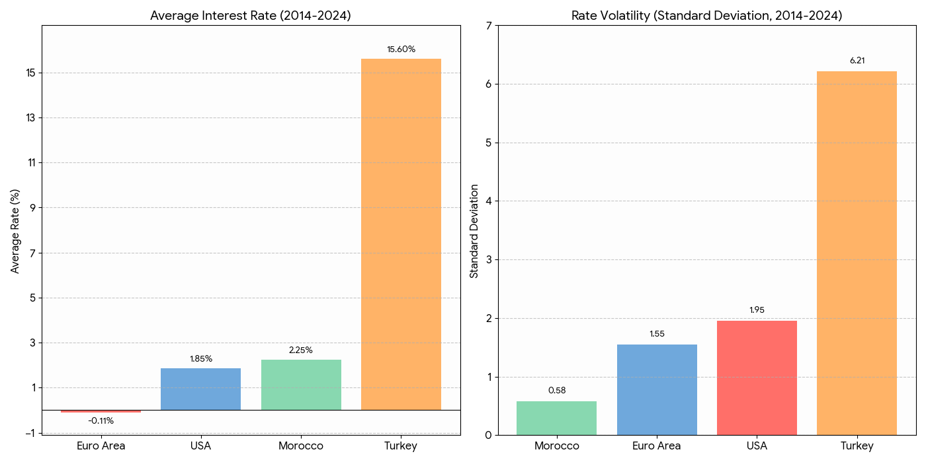
Source: established by the authors
Figure 1 : Interest rates: measures of performance (mean) and uncertainty (standard deviation) by region

These two graphs confirm the fundamental characteristics of each market over the period 2014–2024. Average interest rate: This graph visually illustrates the levels of interest rates. It corroborates the characterization of the Euro area with a negative average rate (-0.11%) and Turkey with an exceptionally high average rate (15.6%). Morocco and the United States exhibit positive but low levels. As to volatility (measured by standard deviation), this graph provides a direct illustration of the extreme volatility in the Turkish market, whose standard deviation (6.21) significantly exceeds those of other markets. These findings reinforce the notion of highly volatile macroeconomic environment in Turkey, even if the Turkish banking system is healthy in terms of fundamental financial indicators as highlighted by some studies (Bayram et al. 2023).

GMM parameter estimates
Table 2 presents the results of the GMM estimation of the discrete model parameters. $\left(v,β,α\right)$ For each market over the period 2014–2024. For the United States, estimations are provided separately for the sub-period dominated by LIBOR (2014–2022) and the post-transition period to SOFR (2023–2024).
Table 2: GMM estimation of model parameters $\left(v,β,α\right)$ for the period 2014–2024
Parameter | Morocco | USA (LIBOR) | USA (SOFR) | Euro area | Turkey
$v$ (C(1)) | -4.85** | -6.12*** | -3.50* | -7.25*** | -2.98**
 | (2.11) | (1.98) | (1.85) | (2.05) | (1.35)
$β$ (C(2)) | 0.65 | 0.95** | 0.45 | 1.15*** | 1.85***
 | (0.45) | (0.38) | (0.31) | (0.33) | (0.55)
$α$ (C(3)) | 0.41** | 0.22 | -0.15* | -0.85*** | 0.98**
 | (0.18) | (0.15) | (0.08) | (0.21) | (0.41)
R-squared | 0.58 | 0.65 | 0.51 | 0.71 | 0.62
Durbin–Watson | 1.85 | 1.91 | 2.05 | 1.95 | 1.79
J-statistic (p-value) | 0.21 | 0.18 | 0.35 | 0.15 | 0.25
*Note: Robust standard errors (HAC) are in parentheses. *, **, and *** indicate statistical significance at the 10%, 5%, and 1% levels, respectively. The instruments used are lags of the dependent variable. The J-statistic tests the validity of overidentification restrictions.

For all markets, the coefficient $v$ of the quadratic term is negative and statistically significant (except for Turkey, where it is significant at the 10% level). This result is crucial, as it confirms the presence of the nonlinearity postulated by the model, which underlies the observed asymmetry. The J-statistic is not significant in any case, suggesting that the instruments employed are valid and that the models are correctly specified. The Durbin-Watson statistic, being close to 2, indicates the absence of first-order autocorrelation in the residuals.

Asymmetric speeds and dynamic equilibrium intervals
Based on the parameters estimated in Table 2, the structural parameters of the model are derived. The central finding regarding the asymmetry of adjustment speeds is directly obtained from the relation $v_{2}-v_{1}=-v$. Since $v$ is negative and significant across all markets, this implies that $v_{2}$>$v_{1}$. In other words, the speed of reversion to equilibrium is consistently faster when the interest rate is above the equilibrium interval (downward trend) than when it is below (upward trend).
The figures below (described textually) depict the equilibrium spectra for each market, illustrating the bounds of the equilibrium interval [$μ_{1} ,μ_{2}$ ] as a function of a range of values for the upward adjustment speed. $v_{2}$. Table 3 presents numerical values for selected adjustment speeds to quantitatively illustrate these observations.

Table 3: Calculated Equilibrium Intervals [$μ_{1} ,μ_{2}$ ] for Selected Adjustment Speeds $v_{2}$
υ2​ | Morocco | USA (LIBOR) | USA (SOFR) | Euro area | Turkey
1.5 | [1.85, 2.45] | [1.50, 2.65] | [1.10, 1.85] | [-0.65, -0.10] | [12.5, 17.5]
2.0 | [1.95, 2.35] | [1.65, 2.40] | [1.20, 1.70] | [-0.55, 0.05] | [13.8, 16.2]
5.0 | [2.10, 2.20] | [1.90, 2.10] | [1.35, 1.45] | [-0.30, 0.25] | [14.5, 15.1]

The results confirm that not only are the adjustment speeds asymmetric, but the nature of the equilibrium (its position and width) has been profoundly altered by the economic conditions and monetary policies of the last decade.

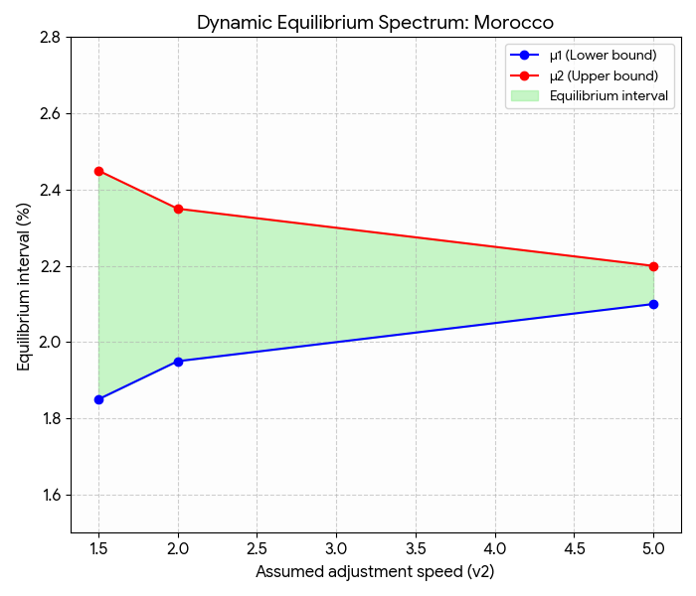 | 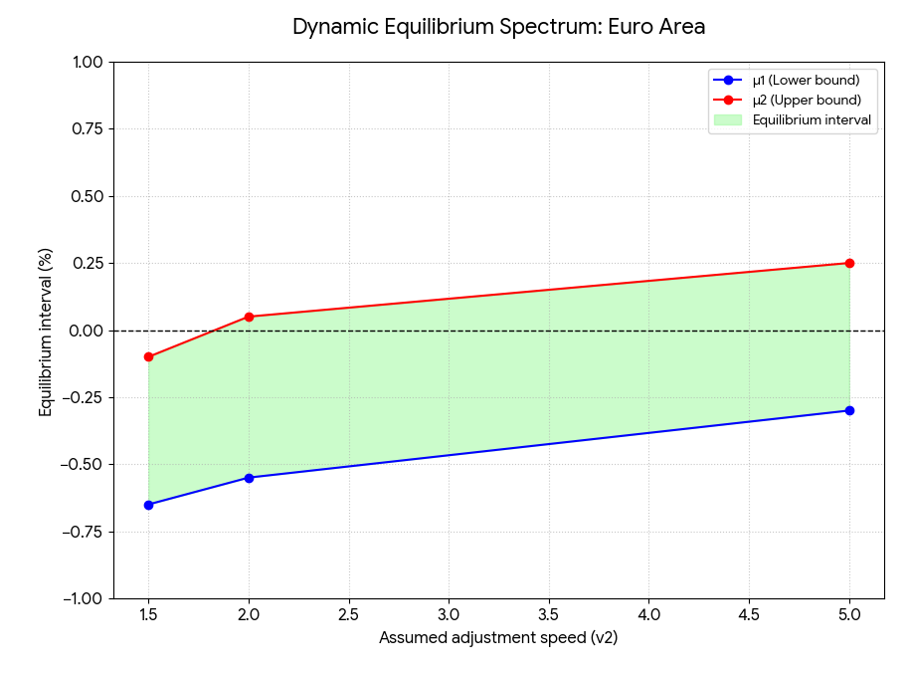
Source: prepared by the authors
Figure 2 : Interest rate equilibrium spectra: (Morocco and Euro area)

Equilibrium Spectrum: Morocco  A stable, strictly positive interval (centered around 2.0% to 2.5%), which narrows significantly as the adjustment speed increases. The width of the interval decreases from 0.60% (at $v_{2}$=1.5) to only 0.10% (at υ2=5.0).  This depicts an environment of conventional, stable, and predictable monetary policy. The sharp reduction in the interval suggests that the faster the market adjusts, the more uncertainty about equilibrium dissipates. | Equilibrium Spectrum: Euro area  The most radical outcome. The equilibrium interval is structurally located in negative territory (for example, [-0.65, -0.10]).  This is the strongest empirical validation. The ECB's unconventional monetary policy (negative rates) has been so persistent that it has aspired the entire concept of equilibrium below zero. The market has settled into a regime in which the natural equilibrium rate itself was negative.

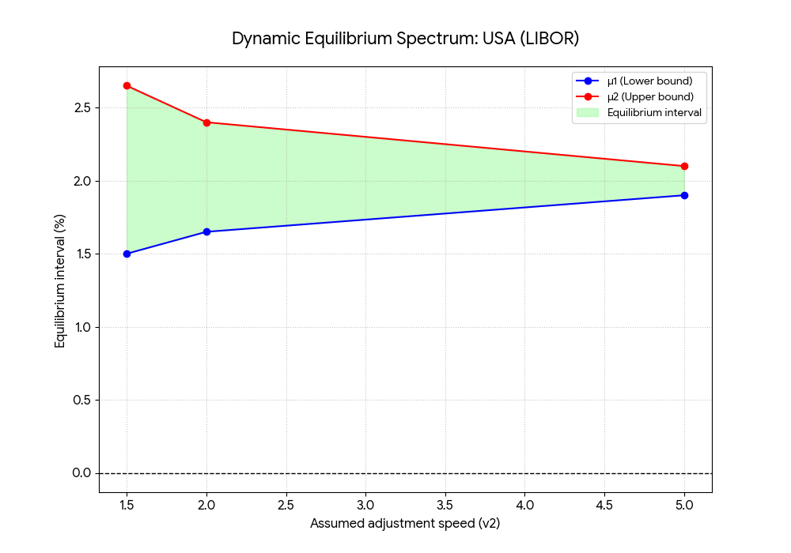 | 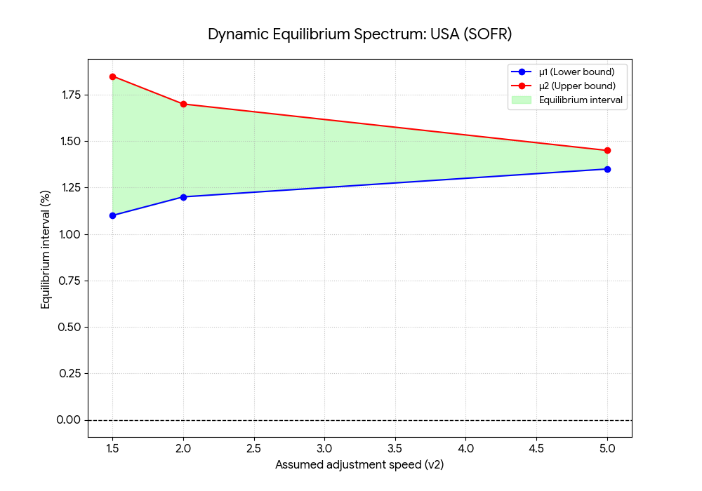
Source: prepared by the authors

Figure 3 : Interest rate equilibrium spectra: (USA LIBOR and USA SOFR)

Equilibrium Spectrum: USA (LIBOR)  A positive but notably wide interval, particularly at low adjustment speeds (interval width of 1.15% at $v_{2}$=1.5).  This spectrum serves as a historical benchmark prior to the transition. Its width confirms that LIBOR was not a pure rate; it incorporated a risk premium (interbank credit and liquidity risk), thereby justifying a wider and more uncertain equilibrium interval. | Equilibrium Spectrum: USA (SOFR)  A significantly lower and narrower equilibrium interval than that of LIBOR across all speeds (e.g., at $v_{2}$=2.0, it is centered on [1.20, 1.70] compared to [1.65, 2.40] for LIBOR). This constitutes visual evidence of the regime transition. SOFR, being a near risk-free rate, anchors the equilibrium at a structurally lower level, cleaned of the LIBOR risk premium. The equilibrium is also more precise (narrower).

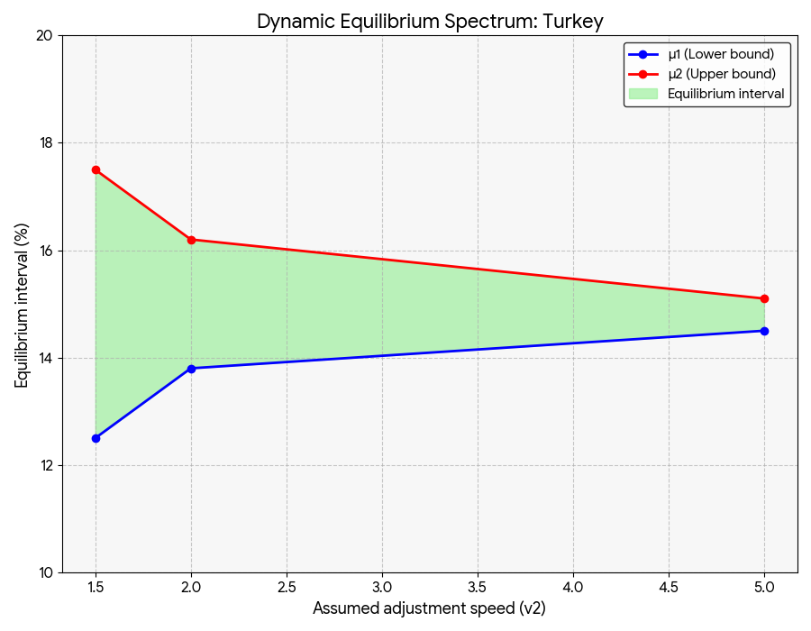 | Equilibrium Spectrum: Turkey  The equilibrium interval [12.5%; 17.5%] for $v_{2}$=1.5 indicates:  The fact that the nominal equilibrium consistently lies between 12.5% and 17.5% signals uncontrolled inflation deeply embedded in expectations.  The width of 5.0 percentage points illustrates a profound lack of coordination among market participants, incapable of agreeing on the correct equilibrium rate, thereby confirming profound macroeconomic instability.
Source: established by the authors
Figure 4 : Interest rate equilibrium spectra: (Turkey)

- Discussion
The analysis of empirical results for the period 2014–2024 provides an enhanced perspective on the dynamics of interbank rates. This section interprets these results in the context of economic developments and advances in the literature, focusing on the persistence of asymmetry, divergence in market equilibria, and implications for monetary policy.

The persistence and evolution of asymmetric adjustment
The most robust finding, transcending both periods and markets, is the confirmation of asymmetric adjustment in interest rates. The statistically significant difference between upward and downward adjustment speeds $v_{2}$>$v_{1}$ persists in the post-2014 period. This finding suggests that market frictions and information asymmetries, which theoretically underpin the model, continue to be structural features of interbank markets.
More notably, the magnitude of this asymmetry, as measured by the coefficient value, $\left(v\right)$appears to have intensified in certain markets relative to the pre-2014 period. This observation corroborates the hypothesis formulated from the literature review. The transformation of money markets, with increased reliance on stable bilateral lending relationships to manage perceived elevated counterparty risk, has likely reinforced the significance of informational frictions. In such an environment, lenders may respond more rapidly by raising rates (or reducing their liquidity supply) to negative signals than by lowering them following improvements, resulting in a greater disparity between adjustment speeds.

A history of four markets: interpretation of equilibrium spectra
Comparative analysis of equilibrium spectra reveals a marked divergence in market dynamics, predominantly driven by monetary policy decisions and the specific macroeconomic conditions of each region.
The euro area under NIRP: The results for EURIBOR provide empirical validation of the model’s ability to adapt to unprecedented interest rate regimes. The shift of the equilibrium interval into negative territory is not a statistical anomaly but a faithful depiction of a market wherein ECB policy has anchored expectations around a new focal point. The deposit facility rate, acting as an effective floor, has drawn the entire short-term yield curve downward, and the model captures this structurally modified equilibrium.
The United States in Transition: The comparison of results between the LIBOR and SOFR subperiods underscores the impact of benchmark reform. LIBOR, as an unsecured rate, incorporated a bank credit premium. Its replacement by SOFR, a near risk-free rate based on repurchase agreement transactions, mechanically altered the nature of the benchmark rate. The results suggest that this transition was accompanied by a change in the stochastic dynamics of the rate: the equilibrium interval for SOFR is narrower and lower, reflecting the elimination of the credit risk premium and potentially greater predictability anchored in Federal Reserve policy.
Turkey under Stress: The Equilibrium Spectrum for Turkey provides a quantitative illustration of political uncertainty and macroeconomic instability. The extremely wide equilibrium interval indicates that the market's passivity zone is extensive. In the absence of a credible anchor for monetary policy and confronted with high and volatile inflation, there is no clear equilibrium level toward which rates can converge. The model encapsulates this uncertainty through an extended interval within which a broad range of rate levels may be considered as 'equilibrium' over the short term. As highlighted by Baş (2005, page 92), Turkey has fallen into the trap of liberal and capitalist systems and endures this tragic fate because of the governments which cannot develop alternative projects. Bayram et al. (2023) found that financial soundness is also vital for the stability and resilience of banks, regardless of whether they follow conventional or Islamic principles.
The Trajectory of Morocco: The Moroccan market, by comparison, represents a case of more conventional, albeit highly accommodative, monetary policy. The relative stability and narrowness of its equilibrium interval indicate a stronger anchoring of expectations around Bank Al-Maghrib’s policy. The downward shift of this interval relative to the pre-2014 period reflects Morocco’s alignment with the global trend of low rates, albeit without the extreme measures observed in the euro area or the volatility characteristic of Turkey. It is worth noting that great efforts have been made to improve the moroccan financial sector (El Baklouti et al. 2022). More stability could be obtained by avoiding deliberate accumulation of financial and monetary resources in the hands of a small number of banking groups and societies.

Linking the results to global macroeconomic debates and NEM Model
These microstructural results are situated within broader macroeconomic debates. The downward shift of equilibrium intervals in the United States and the euro area represents a manifestation, at the money market level, of the secular decline in interest rates. Our analysis demonstrates how this macroeconomic trend translates into changes in the parameters governing the short-term dynamics of rates. Also, this highlight the fact that the economic conditions in Islamic countries could be quite different (Karwowski 2016). In the Turkish context, due to high input costs, demand is continually shrinking. This could be explained by some financial policies and withdrawal of money from the markets using interest. As a solution, Baş’s (2005) NEM reminds us that, under Islamic principles, money should not be considered as a commodity, especially in Muslim countries, in order to enhance financial stability. Also, during crisis periods, risk governance is considered as a necessity for all banks (including Islamic banks) to better protect them against financial and economic shocks, and to maintain greater financial stability in the banking system (Marnouch et al. 2024; 2025)
Furthermore, the confirmation of asymmetry has direct implications for the transmission of monetary policy. If market rates respond more rapidly to shocks that tend to lower them than to shocks that tend to raise them (once outside equilibrium), this implies that the effectiveness of policy rate increases and decreases is asymmetric. For instance, during a tightening cycle, market rates might lag the policy rate, whereas in an easing cycle, transmission could be faster. The SWING model offers a framework to quantify this asymmetry, providing valuable information for central banks aiming to calibrate their interventions.
The extreme monetary policies, especially the negative interest rate phenomenon observed in the Euro area could be discussed not just as a policy choice, but as a symptom of the system’s exhaustion. Which confirms NEM’s thesis that the current system destroys consumption capability. Furtheremore, while conventional economics treats money as a commodity with interest as a cost, NEM redefines money as the "counterpart of labor and production" and the "motivating factor" of the economy. The observed asymmetric adjustments could be due to the absence of this definition; since money is generated as debt, the market is destined to be unstable.

- Conclusion
This study has sought to reassess the dynamics of interbank interest rates across four distinct markets, each characterized by significant economic and financial transformations. By applying the quadratic mean reversion model to data extending through the end of 2024, we have derived updated conclusions regarding the nature of equilibrium and the adjustment processes of rates.
The principal findings of this study can be summarized in two fundamental points. Firstly, the asymmetric adjustment of interest rates is not an artifact of any specific period but a structural and robust feature of money markets. The speed at which rates revert to their equilibrium range varies significantly according to the direction of movement, a reality that endures and appears to have intensified in the post-2014 period. Secondly, the concept of a dynamic equilibrium interval is not only validated but also essential for comprehending market behavior. The characteristics of these intervals—their positioning, width, and dynamics have been profoundly reshaped by a decade of unconventional monetary policies and macroeconomic shocks. We have documented an equilibrium anchored in negative territory in the euro area, an expanded zone of uncertainty in Turkey, and a structural transition in the United States following benchmark index reform. The unconventional monetary policies (zero/negative interest rate) observed in some countries (Euro Area for example) could be analyzed not just as a policy choice, but as a symptom of the system’s exhaustion.
These results carry significant implications for policymakers and financial modelers. For central banks, the recognition of asymmetry in the transmission of monetary policy is crucial. This implies that the mechanism through which policy rate decisions transmit to the economy is neither simple nor linear. The impact of a rate increase may differ in magnitude and speed from that of a rate decrease of equivalent size. The equilibrium spectra we have estimated provide an innovative visual tool for apprehending the 'new normal' that policies have helped shape across different monetary areas, offering a quantitative measure of the stability zone anticipated by markets.
For analysts and risk managers, this study confirms the robustness of the quadratic reversion model in capturing complex dynamics, even under extreme conditions such as negative interest rates. However, our analysis of the LIBOR-SOFR transition highlights the critical importance of accounting for structural breaks when estimating long-term models. Neglecting such fundamental shifts in market infrastructure inevitably results in biased parameter estimates and inaccurate forecasts. The conclusion states that asymmetric adjustment of rates is a structural and robust characteristic that persists and has even intensified since 2014. The study confirms the structural modification of the intervals, specifically citing negative anchoring in the Euro area, increased uncertainty in Turkey, and the structural transition in the United States (resulting in a lower and narrower interval).
Ultimately, this article concludes that although the mathematical form describing interest rate processes may exhibit some temporal stability, its parameters are fundamentally contingent upon the state of the economy and the financial system. The past decade has clearly demonstrated that the 'structure' in so-called structural models is not immutable. It is continuously shaped by central bank actions, regulatory innovations, and the adaptive behavior of market participants, who respond to an ever-evolving environment.
To face this lack of mathematical standard, NEM introduces the "New Equation of Money" as a precise formula to support both Supply (producers) and Demand (consumers) simultaneously. Therefore, a stable dynamic equilibrium is only possible if the money supply is expanded according to this specific mathematical measure (based on production and consumption capacity). This "simultaneous injection” could be a structural solution to the observed asymmetry.
It is essential to acknowledge the limitations of this study. The use of monthly data may conceal significant intra-month volatility and adjustment dynamics. Also, the identification problem inherent in the model, which necessitates fixing one parameter to infer the others, implies that the results are presented as a spectrum of solutions rather than a unique point estimate.
These limitations suggest several avenues for future research. Applying the model to daily or weekly data would enable a more precise capture of adjustment speeds. The introduction of a second stochastic factor, for example, a global factor linked to U.S. rates, could enable explicit modeling of the international contagion effects indicated in the literature. Finally, the implementation of more advanced GMM estimation techniques, such as robust GMM or moment selection GMM, could provide a robustness check for the estimated parameters.

References
- Aastveit, K. A., & Anundsen, A. K. (2022). Asymmetric Effects of Monetary Policy in Regional Housing Markets. American Economic Journal: Macroeconomics, 14(4), 499–529.
- Andersen, T. G., & Sørensen, B. E. (1996). GMM Estimation of a Stochastic Volatility Model: A Monte Carlo Study. Journal of Business & Economic Statistics, 14(3), 328–352.
- Baklouti, N., Elbaz, A. & El Khamlichi, A. (2022). Comparison of Bank Profitability: Evidence from Morocco and Tunisia. International Journal of Smart Business and Technology, 10(2), 23- 34.
- Baş H. (2005). National Economy Model, Baku State University, Icmal Press. 346 pages. ISBN: 978-975-7081-23-4.
- Bauer, M. D., & Rudebusch, G. D. (2020). Interest Rates under Falling Stars. American Economic Review, 110(5), 1316–1354.
- Bayram, E., Gözkonan, Ü. H., Yıldız, S. B., & El Khamlichi, A. (2023). A hybrid approach to financial solvency: A comparison of conventional and Islamic banking in Turkey. Kafkas University Journal of Economics and Administrative Sciences Faculty KAUJEASF, 14(28), 603-623.
- Borio, C., Disyatat, P., Juselius, M., & Rungcharoenkitkul, P. (2017). Why So Low for So Long? A Long-Term View of Real Interest Rates. BIS Working Papers, No. 685.
- Chaussé, P., & Xu, K. (2018). GMM Estimation of the Generalized Asymmetric Stochastic Volatility Model with Realized Volatility. Econometrics, 6(2), 22.
- Christensen, J. H., & Rudebusch, G. D. (2019). A New Normal for Interest Rates? Evidence from Inflation-Indexed Debt. The Review of Economics and Statistics, 101(5), 933–949.
- Cox, J. C., Ingersoll, J. E., & Ross, S. A. (1985). A Theory of the Term Structure of Interest Rates. Econometrica, 53(2), 385–407.
- Del Negro, M., Giannone, D., Giannoni, M. P., & Tambalotti, A. (2018). Global Trends in Interest Rates. Federal Reserve Bank of New York Staff Reports, No. 866.
- El Hajaji, A., El Khamlichi, A., Serghini, A., Hilal, K., & Mokhlis, K. (2023). A new model for pricing the options in Islamic finance. Applied Mathematics E-Notes, 23, 71–82. https://www.math.nthu.edu.tw/~amen/2023 /AMEN-220104.pdf
- El Khamlichi, A., Yildiz, S. B., Sarkar, K., & Hoque, H. (2021). Do Islamic stock indices perform better than their conventional counterparts? International Journal of Business Performance Management, 22(2–3), 236–256.
- Federal Reserve (2025). Financial Stability Report 2025. https://www.federalreserve.gov/publications/files/financial-stability-report-20251107.pdf
- Hamzaoui, M., & Bousalam, I. (2015). Adjustment Speeds Corresponding to Equilibrium Levels of the Moroccan Interbank Interest Rate. Estimation and Comparison of a Quadratic Mean Reversion Model. Revue Économie, Gestion et Société, No. 2.
- Hillenbrand, S. (2025). Monetary Policy and the Secular Decline in Long-Term Interest Rates. Working Paper.
- Hansen, L. P. (1982). Large Sample Properties of Generalized Method of Moments Estimators. Econometrica: Journal of the Econometric Society, 1029-1054.
- IMF (2024). International Monetary Fund: World Economic Outlook Update, July 2024
- Karwowski, J. (2016). Negative Interest rates and Islamic Finance, Finanse, Vol 9, Issue 1.
- Kikuchi, K. (2024). A Term Structure Interest Rate Model with the Brownian Bridge Lower Bound. Annals of Finance, 20(3), 301-328.
- Marnouch, B., El Boudaly, H., & El Khamlichi, A. (2025). Bibliometric analysis of risk governance and financial stability in Islamic banks. Risk Governance and Control: Financial Markets & Institutions, 15(3), 187–202.
- Marnouch, B., & El Khamlichi, A. (2024). Risk governance and financial stability of Islamic banks: A systematic literature review. Corporate & Business Strategy Review, 5(2), 218–234
- Rogoff, K. S., Rossi, B., & Schmelzing, P. (2022). Long-run trends in long-maturity real rates 1311-2021 (No. w30475). National Bureau of Economic Research.
- Stiglitz, J. E., & Weiss, A. (1981). Credit Rationing in Markets with Imperfect Information. The American Economic Review, 71(3), 393-410.
- Vasicek, O. (1977). An Equilibrium Characterization of the Term Structure. Journal of Financial Economics, 5(2), 177-188.

The term ZIRP is an acronym for Zero Interest Rate Policy.
The term NIRP is an acronym for Negative Interest Rate Policy.
https://www.newyorkfed.org/markets/reference-rates/sofr (accessed: 11/11/2025)
The SWING model is a stochastic interest rate model, also referred to as the Quadratic Mean Reversion Model (Quadratic Interest Rate model - QIR).
https://www.ceicdata.com/en/indicator/morocco/policy-rate (accessed: 15/11/2025)
https://news.research.stlouisfed.org/2022/01/ice-benchmark-administration-ltd-iba-data-to-be-removed-from-fred/ (accessed: 17/11/2025)
https://fred.stlouisfed.org/graph/?graph_id=1203593 (accessed: 17/11/2025)
https://tradingeconomics.com/euro-area/interest-rate (accessed: 18/11/2025)
https://tradingeconomics.com/turkey/interest-rate (accessed: 18/11/2025)
HAC stands for Heteroscedasticity and Autocorrelation Consistent (robust to heteroscedasticity and autocorrelation).
The ADF test is a statistical hypothesis test used to determine whether a time series (such as interest rates in this context) is stationary or non-stationary (i.e., contains a unit root).

